PSAT Webquest

Instructions:
- Make a copy of this document. Click “File” then “Make a Copy.”
- Change the title of the new document to your first initial and last name PSAT Webquest.
ex: “S Finch PSAT Webquest”
- Complete all of the steps below. Use the chart in Step 2 to complete the item analysis. Be sure to answer all question in this document.

Step 1: Log In to CollegeBoard
Log in at www.collegeboard.org and search the free tools to help you improve your SAT and PSAT scores and prepare for college. If you do not have an account, please follow the steps online to create one. If you are new to CollegeBoard, create an account and write down your username and password on receipt sheet. MAKE SURE TO USE YOUR OFFICIAL NAME to create your account, as this will be linked with your PSAT and SAT test results. **View the video at https://harrisonpsat.weebly.com/ for a video tutorial on logging in to your CollegeBoard account.
Step 2: Item Analysis
- Access your online score report from the 2018 administration. Click “View Details.”
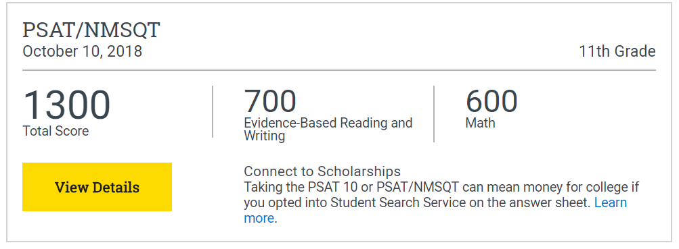

- Select “Test Questions” and scroll down to “Filters.”
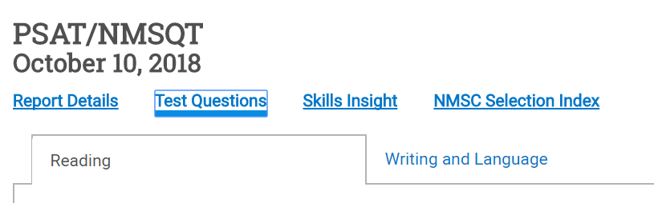

- Under “Filters,” click “Incorrect Answers” from the drop-down menu.
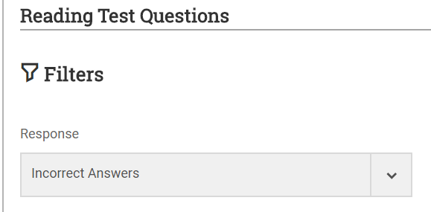

- Analyze your incorrect answers from both the “Reading” and “Writing and Language” sections. Complete the item analysis chart below. To view the question and passage, click the hyperlinked question number. Complete a row on the item analysis chart for at least five questions from each section; if you did not miss five questions per section, just complete a row on the item analysis chart for each of the ones you missed.
Missed Question Number | Correct Answer | Your Answer | Why You Chose the Answer You Chose | Why the Correct Answer is the Best Answer
Example: 7 | A | C | The previous question asks which aspect of carpentry the narrator most enjoyed. “C” describes the men’s insistence on using the most appropriate tool for a job, and I connected that to the “jargon” in my answer to question 6. | The previous question asks which aspect of carpentry the narrator most enjoyed. The answer, that the narrator most enjoyed learning new jargon, is best supported in the third paragraph: “Above all, I liked Bill and Dave because of the banter between them. The two of them talked incessantly about the work in a language that was new to me.”
Missed Question Number | Correct Answer | Your Answer | Why You Chose the Answer You Chose | Why the Correct Answer is the Best Answer

Step 3: Analyze Your AP Potential
- Click “Back” until you return to your score report screen. Click “AP Potential” on the top right side of your screen.
- View the “AP Potential Key” and familiarize yourself with the three-dot system for analyzing AP Potential.
- Answer the following questions:
  - Have you taken any AP classes? If so, which ones?
  - Do the results of your AP Potential report surprise you? Why or why not?
  - If your AP Potential report indicates potential for any AP courses you have not taken, do any of these courses interest you?
- Now select a major you might enjoy from the drop-down menu.
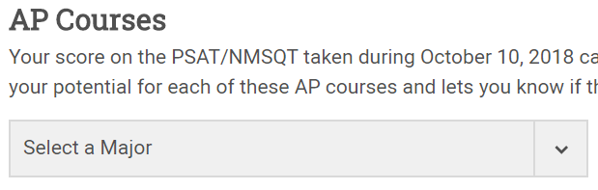
  - Which AP courses match your potential major?

Step 4: Roadmap to Careers
- Scroll to the bottom of the screen and select “Roadmap to Careers.”
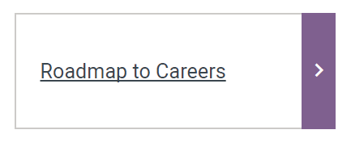
- Complete all steps on the Roadtrip Nation until you receive your suggested careers. Write your suggested careers here:
- Do any of these careers interest you? What can you do to work toward a career in one/any of these fields?

