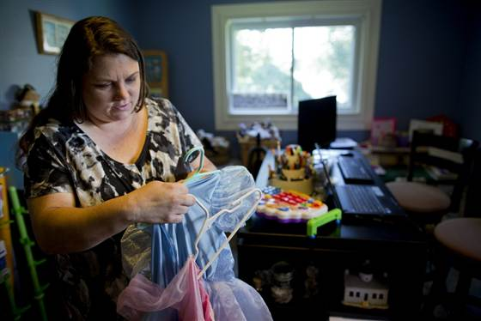

The state of the American Dream is uncertain
July 5, 2013 at 3:15 AM ET by John Makely / NBC News
Mary Conti sorts through her daughters' princess dresses before listing them for sale on a consignment website. Conti thinks it's possible to climb the economic ladder, but it takes both luck and hard work.
Ah, the enduring American Dream: The idea that anyone who works hard enough can climb the ladder and achieve success: The big home in the suburbs, the luxury cars in the garage, the kids off to a good college and the retirement in a sunny locale.
The reality is more complicated.
Although the economy is improving slowly, experts say the deep recession and weak recovery may have exacerbated decades-long trends that were already making it tough for Americans to move up the economic ladder and, perhaps, achieve the American Dream.
The incredibly weak job market of the past five years, especially, may mean that more people feel like they are doing everything right – working hard, going to college, following the rules – and still aren’t getting ahead.
“If there’s not enough jobs in general, then we have a systemic problem that threatens the American Dream,” said Steven Fazzari, an economics professor at Washington University in St. Louis who recently taught a course on the economic realities of The American Dream.
Americans also are known for their resilience, and Pew Charitable Trusts data has shown that about two-thirds of Americans believe they have achieved, or will achieve, the American Dream. But a separate Gallup poll from last year found that only about half of Americans are satisfied with the opportunity for a poor person in America to get ahead by working hard.
Mary Conti is not one of them.
Conti, 42, was the first person in her family to go to college, and at first that degree seemed to be a springboard into a middle class life. Conti was laid off from her job as a reporting analyst about a year ago, and she and her husband have since fallen badly behind on their bills.
A year after Conti was profiled by NBC News for a story on Americans who fear falling down the economic ladder, she said her experience has left her feeling like it also takes luck to climb the economic ladder.
“I think it’s still possible, I guess,” Conti said. “It’s not as much hard work, I think, as it used to be. It’s hard work, but it’s also luck.”
The reality is that even in good times, it has been difficult, and rare, for Americans born very poor to end up rich.
“In the United States, people who are coming from low-income families are highly likely to be low-income themselves,” said Erin Currier, director of the Pew Charitable Trusts’ Economic Mobility Project. “That sort of rags to riches story … is very unlikely.”
That may come as a surprise to many people who feel like they are doing better, financially, than their parents.
Mary C. Daly, senior vice president with the Federal Reserve Bank of San Francisco, said her research showed that about two-thirds of adults do have higher family incomes than their parents, after adjusting for inflation.
But those increases have come as our standard of living generally has improved, and very few people are doing better enough to make a move up the economic ladder.
“If you want to think about going up and down the economic ladder, you just don’t see it,” Daly said.
Overall, about one-third of the households that Pew’s Currier studied could be classified as upwardly mobile, meaning that they had higher household income and were at a higher point in the income distribution ladder than their parents.
The Pew researchers also found that just 4 percent of people who grew up in a household at the bottom fifth of the income ladder made it to the top fifth as adults.
Fazzari, the economics professor, said the American Dream may have been most validated in the period after World War II. But he said said most Americans have been grappling with stagnating wages since at least the 1980s. The gap between rich and poor also has widened in the past couple of decades as wages for the nation's wealthiest workers have grown substantially faster than for everyone else.
For many people, things have likely gotten even tougher recently, as Americans have dealt with the triple whammy of the housing bust, financial crisis and high unemployment. The nation’s median household income in 2011 was nearly 9 percent lower than in 1999, after adjusting for inflation.
The economic shocks associated with the recession, such as a stint of unemployment, can be especially devastating to a low-income household’s long-term economic prospects, according to Pew’s Currier.
To pay rent and buy food when there isn’t a steady paycheck, Currier said some people with less resources are forced to drain the savings accounts meant for retirement or paying for college. Others may turn to things like payday loans, putting themselves into pricey debt.
“It actually can really, really derail what were otherwise families that had a bit of a foothold on the middle class,” Currier said.
Heather Wyatt-Nichol, director of the Masters in Public Administration program at the University of Baltimore, said her research has shown that even when some of the nation’s poorest people are able to move up the economic ladder, they sometimes end up falling back down a few years later.
She argued that perhaps Americans need to rethink the definition of the American Dream, putting less focus on having a huge house and lots of cars and more focus on building successful communities.
“We all want to be able to support ourselves and our family, and have a decent standard of living,” she said. “But in many ways, I think we need to scale back what the American Dream means to us.”

